Hieroglyph | Sound | Example
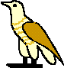 | Short A | cat
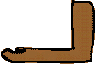 | Long A | bake, pail
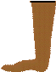 | B | bat
 | Soft C | mice
 | Hard C | cat
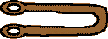 | CH | child
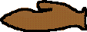 | D | dog
 | Short E | egg
 | Long E | bee
 | F | fish, phone
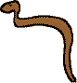 | Soft G | judge
 | Hard G | grape
 | H | her
 | Short I | him
 | Long I | hide
 | J | jump
 | K | kite
 | L | lake
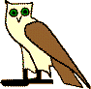 | M | mother
 | N | nile
 | Short O | dog, tall
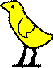 | Long O | coat
 | OO | food, rude
 | OO | cook, push
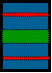 | P | pin
 | QU | quick
 | R | run
 | Soft S | sit
 | Hard S | days
 | SH | shark
 | T | tall
 | soft TH | thumb
 | hard TH | the
 | short U | cut
 | long U | cute
 | V | vine
 | W | win
 | X | fox
 | hard Y | yellow
 | Y like e | ready
 | Y like i | fly
 | Z | zebra

