Handcraft: | Animal Mask
Handcraft: | African Mask

Requirements: | Masks interest badge

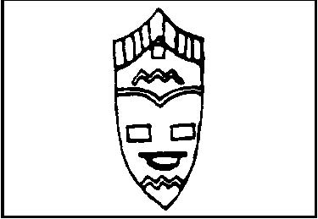

Do any THREE of the following:

- Make a simple papier-mâché mask.

- Make an animal mask.

- Make an African mask.

- Draw, paint or crayon three designs of primitive ceremonial masks.

Singing: | Come a-hunting

Tune: Frere Jacques

Come a-hunting, come a-hunting,
Wolf Cubs all, Wolf Cubs all,
Out into the jungle, out into the jungle,
Hear the call, hear the call.

Please don’t forget to evaluate this programme:

