Cheetahs are mostly found in **sub-Saharan Africa** and in eastern and southern African parks. Some of the animals can still be found in southern Algeria, northern Niger and Iran. They like **dry**, open **grasslands** where they can pick up speed to kill prey.

The cheetah is the fastest land animal in the entire world. It can reach a maximum speed of approximately 113 kmph. Their scientific name is Acinonyx Jubatus. They have slender bodies with thin legs and a long tail. They are built for speed. Cheetah cannot climb trees and have a poor night vision. They have amazing eyesight during the day and can spot their prey from 5 km away. They are carnivores and generally feed on smaller antelopes like steenbok, duiker, gazelles, hares etc. Female cheetahs have a gestation period of around 3 months and the litter size is 2-4 cubs. They mate throughout the year and do not have any specific breeding season.

[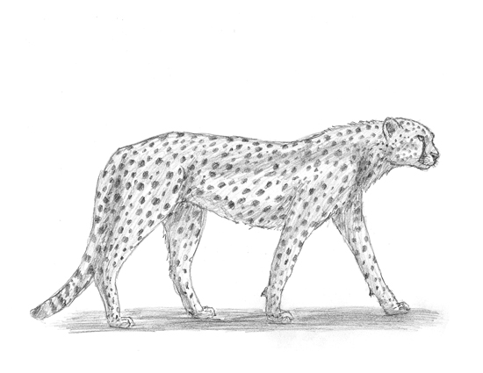](http://www.google.co.za/url?sa=i&rct=j&q=&esrc=s&source=images&cd=&cad=rja&uact=8&ved=0ahUKEwja0NLGl6PXAhWPmLQKHcYWAosQjRwIBw&url=http%3A%2F%2Fhow2drawanimals.com%2F&psig=AOvVaw2XKK8yOb-mDRfE2CJFARK_&ust=1509825245562515)

Our planet is home to five species of rhinoceros. These brilliant beasts are known for their awesome, giant horns that grow from their snouts – hence the name “rhinoceros’, meaning “nose horn”. These incredible creatures are some of the biggest animals in world! The largest of the five species is the white rhino, which can grow to 1.8m tall and and weigh a massive 2,500kg – that’s the weight of 30 men!

Rhino habitat ranges from savannas to dense forests in **tropical** and **subtropical** regions. FOOD: Rhinos are herbivores, meaning they eat only plants. White rhinos, with their square-shaped lips, are ideally suited to graze on grass.

[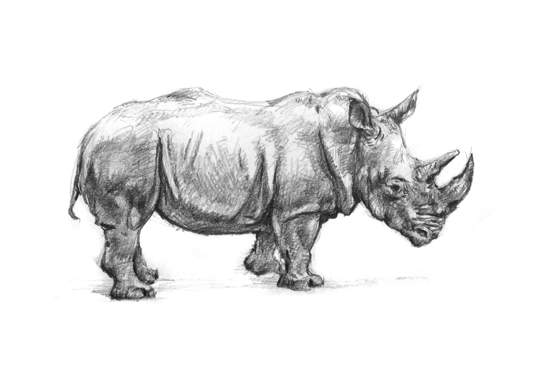](http://www.google.co.za/url?sa=i&rct=j&q=&esrc=s&source=images&cd=&cad=rja&uact=8&ved=0ahUKEwjN9-y7mKPXAhURalAKHdAGCb4QjRwIBw&url=http%3A%2F%2Fwww.artofwei.com%2Fdrawings%2Fdrawings-on-youtube%2F&psig=AOvVaw3FrDFHsYmV1xBBt9DS0URj&ust=1509825474934970)

Giant pandas (often referred to as simply “pandas”) are black and white bears. In the wild, they are found in thick bamboo forests, high up in the mountains of central China. These magnificent mammals are omnivores. But whilst they will occasionally eat small animals and fish, bamboo counts for 99 percent of their diet. These guys are BIG eaters – every day they fill their tummies for up to 12 hours, shifting up to 12 kilograms of bamboo!

Unlike most other bears, pandas do not hibernate. When winter approaches, they head lower down their mountain homes to warmer temperatures, where they continue to chomp away on bamboo!

[](http://www.google.co.za/url?sa=i&rct=j&q=&esrc=s&source=images&cd=&cad=rja&uact=8&ved=0ahUKEwj7tdGjmqPXAhXMKlAKHeqSDbIQjRwIBw&url=http%3A%2F%2Fwww.imgrum.org%2Ftag%2Frichardsymonds&psig=AOvVaw1risv1uur1-0kInUnMUGUD&ust=1509825976727650)

The largest animals to have ever lived on Earth, blue whales can grow to over 30m long and weigh more than 130,000kg – that’s longer than three buses and heavier than three lorries! Pretty much everything about the blue whale is massive. It’s tongue weighs as much as an elephant, its heart is the size of a car and its blood vessels are so wide you could swim through them. Blue whales can be found in all of our planet’s oceans, except the Arctic, usually swimming alone or in groups of two to four.

**Antarctic** blue whales, B. musculus intermedia, are found near Antarctica during the summer months. Captures off the coast of Chili and Namibia suggest they migrate north in the winter.

[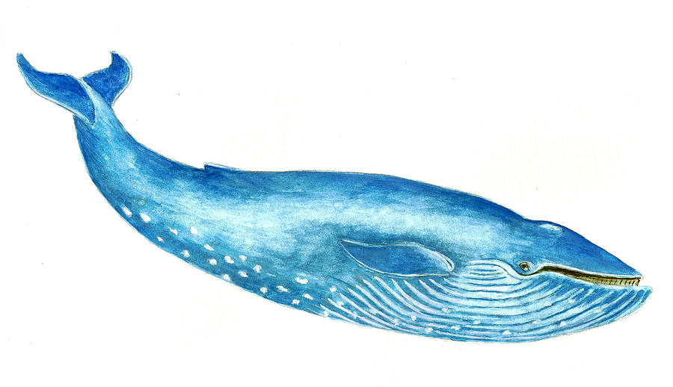](https://www.google.co.za/url?sa=i&rct=j&q=&esrc=s&source=images&cd=&cad=rja&uact=8&ved=0ahUKEwiXlsLNmqPXAhUKEVAKHcApDJMQjRwIBw&url=https%3A%2F%2Fwww.pinterest.co.uk%2Fpin%2F123708320986373799%2F&psig=AOvVaw1xkmWExf2XoHEChoiAgRtf&ust=1509826044114297)

**In 1924, the first velociraptor remains were discovered in Mongolia’s Gobi Desert by the American Roy Chapman Andrews – the man believed to be the inspiration for the Indiana Jones character!**

**Although small, velociraptors were quite clever and could move very fast (the name means ‘speed thief’), using their long tails for balance as they ran after their tasty prey. These carnivorous creatures hunted in packs, and probably ate mostly small lizards and mammals. They may have even eaten other velociraptors’ babies.**

**Deserts:** desert present a harsh ecological challenge to all forms of life, and dinosaurs were no exception. The most famous desert of the Mesozoic Era, the Gobi of central Asia, was prowled by three very familiar dinosaurs.

[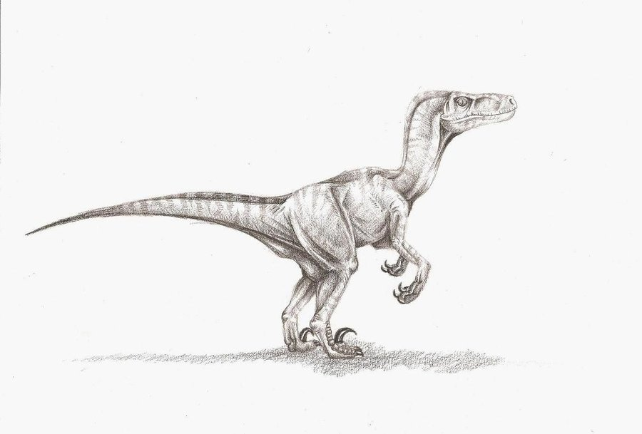](https://www.google.co.za/url?sa=i&rct=j&q=&esrc=s&source=images&cd=&cad=rja&uact=8&ved=0ahUKEwiorouqnKPXAhVHa1AKHUwbCxAQjRwIBw&url=https%3A%2F%2Fwww.pinterest.com%2Fpin%2F67342956901233620%2F&psig=AOvVaw1MbbwuXtrJ_u57k8qrBW_w&ust=1509826354546376)

**The most famous dino of them all, the T-rex was armed with jaws which remain the most powerful weapon nature has ever created. Its thick, sharp teeth could rip almost 100kg of flesh off its victims in a single bone-crunching chomp! It was also one of the smartest of the meat-eating dinosaurs with a brain twice as big as those of other giant carnivores. More than 20 almost-complete skeletons have been found, and the most perfect, nicknamed Sue, was unearthed in South Dakota, USA, 20 years ago. Experts together spent more than 25,000 hours restoring Sue’s bones for exhibition.**

**Swamp forests:**swamp forest are very similar to riparian forests, with one important exception, the swamp forests of the late Cretaceous period were matted with flowers and other late-evolving plants, providing an important source of nutrition to huge herds of duck-billed dinosaurs such as Lambeosaurus. In turn, these "cows of the Cretaceous" were preyed on by smarter, more agile theropods, ranging from Troodon to Tyrannosaurus Rex.

[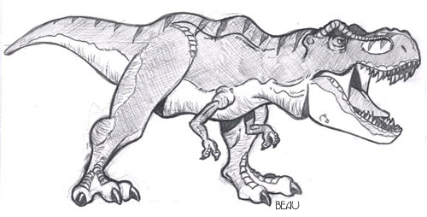](http://www.google.co.za/url?sa=i&rct=j&q=&esrc=s&source=images&cd=&cad=rja&uact=8&ved=0ahUKEwjkvNjAnKPXAhXSEVAKHajdBpMQjRwIBw&url=http%3A%2F%2Fmoziru.com%2Fexplore%2FDrawn%2520head%2520t%2520rex%2F&psig=AOvVaw1PqvENJkOwzz58lo63Uwrq&ust=1509826587406667)

The Mexican Wolf (Canis lupus baileyi) is the rarest, most genetically distinct subspecies of the Grey Wolf in North America. Until recent times, the Mexican Wolf ranged the Sonoran and Chihuahuan deserts from central Mexico to western Texas, southern New Mexico and central Arizona.

By the the turn of the century, reduction of natural prey like deer and elk caused many Mexican Wolves to begin attacking domestic livestock, which led to intensive efforts by government agencies and individuals to eradicate the Mexican Wolf. Mexican wolves prefer to live in mountain forests, grasslands and shrub lands.

[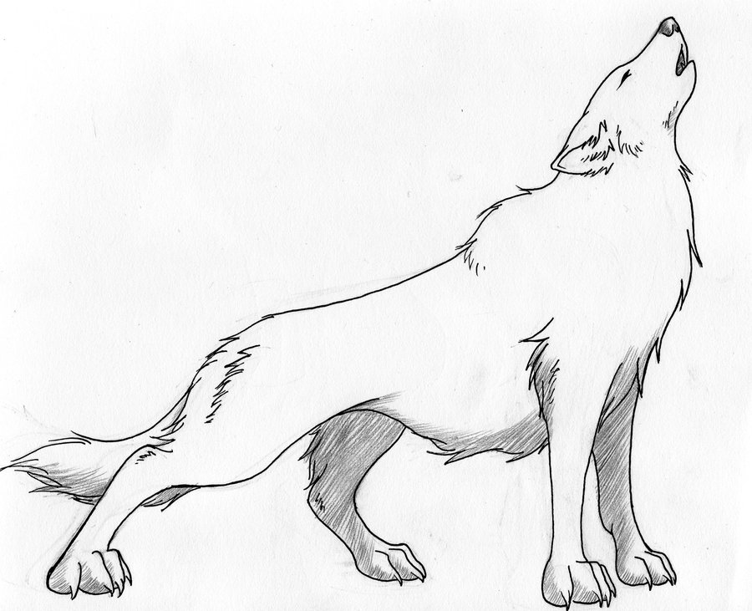](https://www.google.co.za/url?sa=i&rct=j&q=&esrc=s&source=images&cd=&cad=rja&uact=8&ved=0ahUKEwi12aOxoKPXAhUFPVAKHeMLAnQQjRwIBw&url=https%3A%2F%2Fwww.pinterest.com%2Fpin%2F486529565972920717%2F&psig=AOvVaw3TWfcejm5_w4-SuJx0qWhR&ust=1509827592789591)