Spray paint the bowls and lid black.

In the bowl, punch small pin holes in the shape of the constellations, using the template below.

On the lid, build the circuit as follows:

* Tape/glue the LED with two wires to the centre of the lid

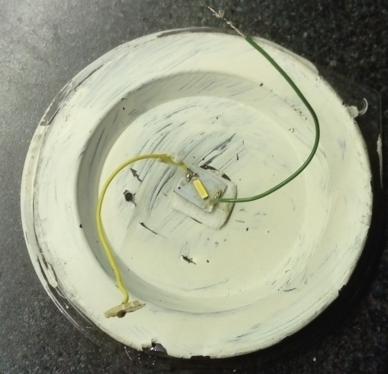

* Connect the batteries together with insulation tape, facing opposite directions and touching the veroboard piece provided.  Test that current is flowing

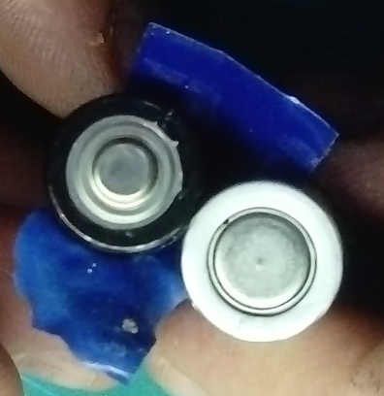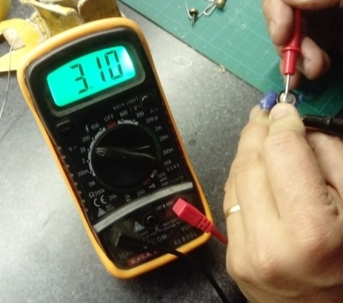

* Place the small veroboards connected to LED onto a strip of insulation and attach to the battery pack

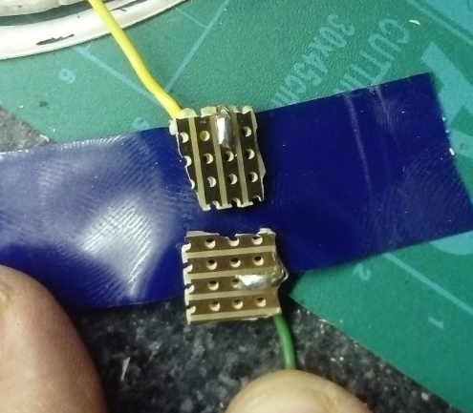

* Bend the paper clip into the shape of a switch.  Measure the distance and place the two split pins at the measured distance by pushing the legs through the lid

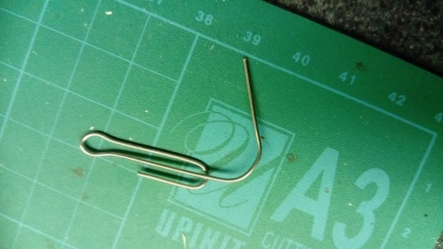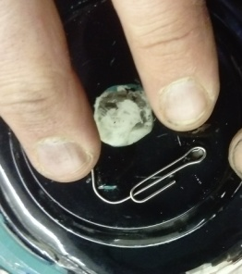

* Connect the wires to the split pins

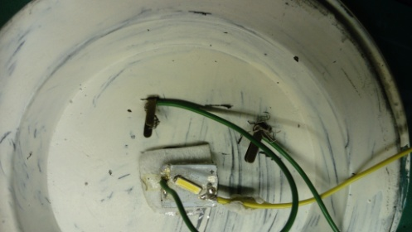

* Paper clip acts as the switch

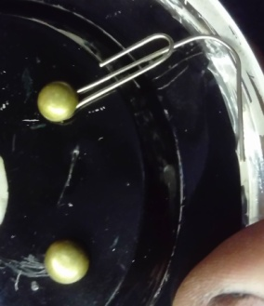

* Attach battery pack to side of the lid and tape in place

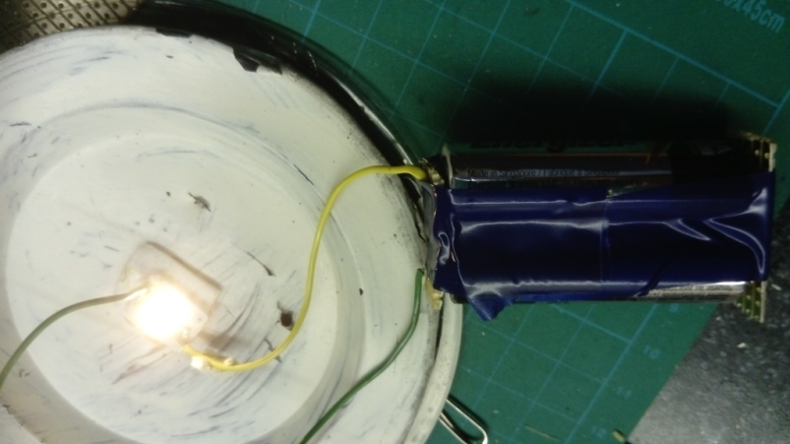

* Place the bowl back on the lid.  Use the paper clip to switch on and off

