Chess Pieces
Name | Picture | Symbol | Description | How it moves
1 King | 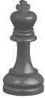 | 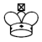 | The King is the most important piece in the army. If he is captured, the game is lost. | 1 square in any direction (forward, back, across or diagonally)
1 Queen | 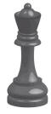 |  | The Queen is the most powerful piece. | Any number of squares in any direction
2 Castles | 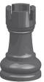 | 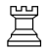 | Castles are strong pieces which are good both at attacking the enemy and defending the King. Sometimes the Castle is called a Rook. | Any number of squares forward, back or across (but not diagonally)
2 Bishops | 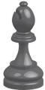 | 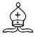 | Bishops are good at attacking late on in the game. Because they move diagonally, they always stay on the same colour square that they started on. | Any number of square diagonally
2 Knights | 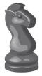 | 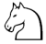 | Knights are at their best when there are lots of pieces on the board, and they can use their ability to jump over other pieces. | L shaped- two squares forward (or back) and one square across; or two squares across and one square forward (or back). The Knight can jump over other pieces while doing this.
8 Pawns | 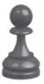 | 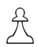 | Pawns are the foot soldiers in the army. They gradually advance on the opposing army, but also need to defend the King. | Usually one square forward. If it is capturing an opposing piece, however, it moves one square forward diagonally. Each pawn may move two squares forward the first time it moves. If it does, it cannot capture in the same move. Pawns can never move backwards.

