1st Randburg Cubs
Jungle Book Quiz
Match the columns below. If the light shines, you have it correct.
Know 8 character names and their characteristics to sign off your silver wolf advancement.
Raksha | (Black panther)  Strong, silent and a true friend
Akela | (Brown bear)  Persistent, loving and a great friend
Bagheera | (Mother Wolf)  Caring and fierce
Baloo | (Kite)  Eagle eyes, swift and reliable
Chil | (Wolf)  Leader of the Pack, Strength and cunning

1st Randburg Cubs
Jungle Book Quiz 2
Match the columns below. If the light shines, you have it correct.
Know 8 character names and their characteristics to sign off your silver wolf advancement.
Kaa | (Jackal)  Mean, tale-teller and a nuisance
Riki Tiki Tavi | (Tiger)  Bully and a killer
Tabaquai | (Rock python)  Strength and gentleness in one
Shere Khan | (Elephant)  Strong, wise, fair and has a good memory
Hathi | (Mongoose)  Fast and brave

1st Randburg Cubs
Woodcraft Sign Quiz
Match the columns below. If the light shines, you have it correct.
Know how to make and recognise at least ten woodcraft signs to sign off your silver wolf advancement.
 | Message and distance/direction  Pebbles are easiest for this sign.
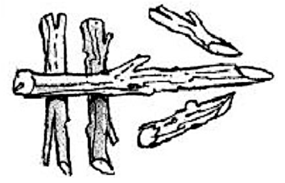 | Turn left.  Can be made with stones, twigs or grass
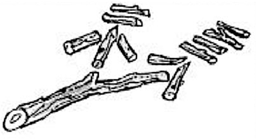 | Gone home.  Make with pebbles or draw in sand
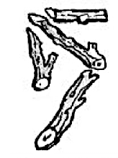 | Obstacle ahead.  Twigs are best for this.
 | Group split  Sticks, pebbles can be used

1st Randburg Cubs
Woodcraft Sign Quiz 2
Match the columns below. If the light shines, you have it correct.
Know how to make and recognise at least ten woodcraft signs to sign off your silver wolf advancement.
 | Carry straight on  Leaf, twigs or a branch placed in a different type of tree
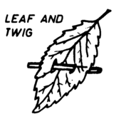 | Water and direction  Sticks , pebbles or drawn in the sand
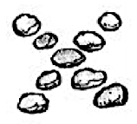 | Carry straight on  Stones, twigs and grass
 | Turn right  Can be made with twigs, grass or stones
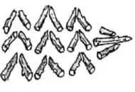 | Don’t go this way  Pebbles, sticks or drawn

