**Binary Code**

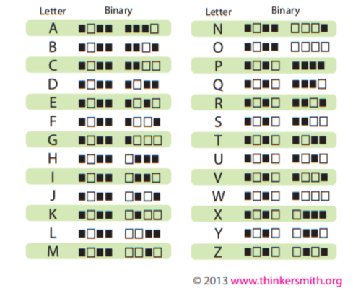

(White = 1 and Black = 0)

|  |  |  |  |  |  |  |  |  |
| --- | --- | --- | --- | --- | --- | --- | --- | --- |
|  |  |  |  |  |  |  |  |  |
|  |  |  |  |  |  |  |  |  |
|  |  |  |  |  |  |  |  |  |
|  |  |  |  |  |  |  |  |  |
|  |  |  |  |  |  |  |  |  |
|  |  |  |  |  |  |  |  |  |
|  |  |  |  |  |  |  |  |  |
|  |  |  |  |  |  |  |  |  |
|  |  |  |  |  |  |  |  |  |