What has four fingers and a thumb but is not living?

Glove

I can only live where there is light, but I die if the light shines on me. What am I

Shadow

What gets wet when drying?

Towel

Give me food and I will live. Give me water and I will die. What am I?

Fire


I believe in you

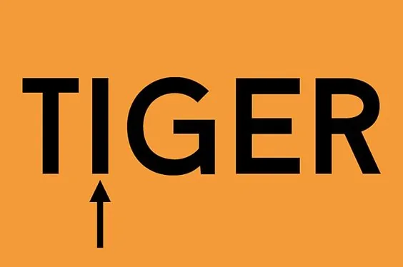

The eye of the tiger

Stick around
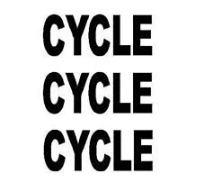
Tricycle
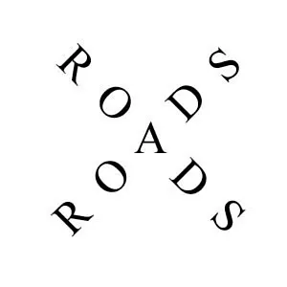
Cross roads

If a rooster lays an egg on top of a barn roof, which way will the egg roll-off?
Roosters don’t lay eggs – hens do!

What starts with an E, ends with an E, but only has one letter?

An envelope

What’s black when it’s clean and white when it’s dirty?

A blackboard

What has many keys but cannot open a single lock?

A piano

If you were running a race and passed the person in 2nd place, what place would you be now?

If you passed the person in 2nd place, you’d be in 2nd place. You passed the person in second place, not first. You could only be in the first place if you passed the person who was in the first place before the race started.

Johnny’s mother had three children. The first child was named April. The second child was named May. What was the third child’s name?

Johnny

